Roomba Watching Notes

NJRB2 | MVS9 | FA296

This document contains our notes written up throughout the movement investigation of the Roomba.

# Notes

## Self Perspective

* It doesn’t have any specific pattern
* The Roomba will turn again at least 10 seconds after the initial turn
* Roomba will spiral once it senses that it is in a large area
* If it senses a block, it will try and go around it (as seen in Fig.2)
* The Roomba will detect whether or not it is on a higher level, as whenever one of the wheels reaches the edge, it stops itself

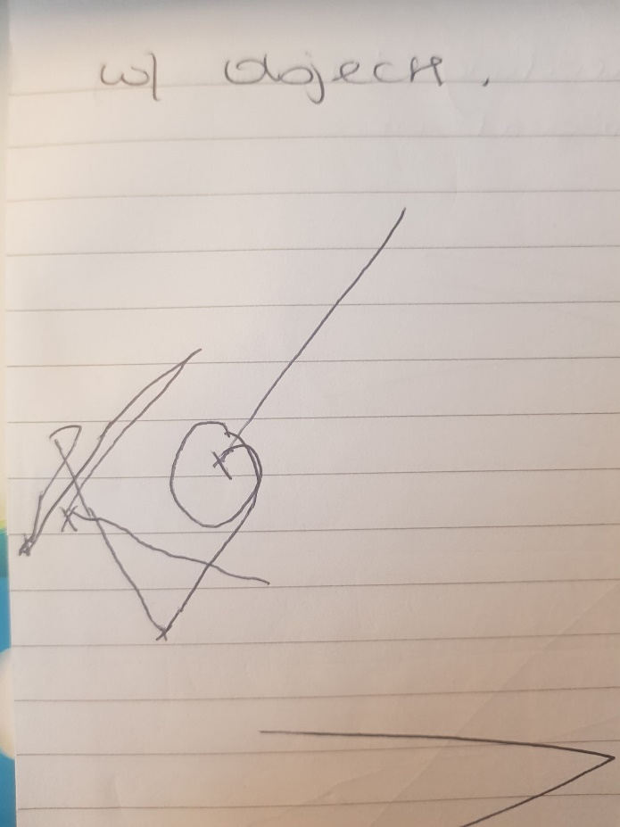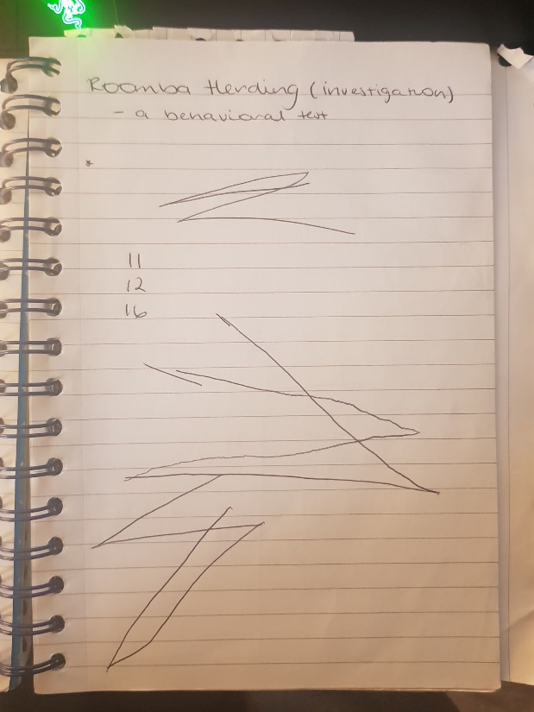

Fig. 2

Fig. 1

## iRoomba Response

We have also reached out to iRobot, makers of the Roomba module, and have confirmed that Roomba patterns cannot be predicted as every model calculates the optimal cleaning path. Depending on the path, it varies its behaviour and modes. We can, however, control the movement of the Roomba by pressing the ‘CLEAN’ button three times to make it go in a straight line. They have also stated that the spiral movement mentioned earlier is called a ‘Spot Clean Mode’.